Rallye Charlevoix 2016

Supplementary Regulations

Version du 2016 sept 12

Welcome to all of you at the eighth edition of the Rallye de Charlevoix, which is still marked by a great event. Year after year, the organizing committee makes every effort to greatly improve the event. Listening to your comments and suggestions is one of our priorities so that you are satisfied. Without you, we could not remain much less have the success that we know. We hope that the 2016 edition once again meet your expectations. We must not forget that organizing a car rally in a small region as here leads to a restricted choice in terms of infrastructure, so we ask you to be understanding and assure you that the team is the maximum to ensure your complete satisfaction.

It begins Rally Charlevoix with the opening of the event Thursday, October 20 under a formula 5-7 with the exposure of your rally cars at the Casino de Charlevoix at 183 rue Richelieu, La Malbaie. There will be a free practice session this year at a cost of $ 60 Friday, October 21, from 9:15 to 12:00. For this, we will use a portion of the Pax. As for the special in the city of Clermont is always present with his jump. So the special Clermont, it will first asphalt, then gravel, then finish on the asphalt!
The banquet will be out this year to one's budget and organization. If things change along the way, you will quickly know. I advise you to choose your accommodation from those indicated in this document because they are institutions that financially support the event. Please also mention your hotel reservations during your stay is in the Rallye de Charlevoix. Furthermore the Mc Café La Malbaie is one of our partners and will provide drivers and co-drivers 50% off the trios of your choice by presenting the coupons that are given to you in your registration envelope, so I encourage you to visit this place during your stay in Charlevoix.

Finally, I wish you a very good rally and lots of fun! Be careful ! ☺ Your presence is essential to our event because without you, there would not! Thank you a lot! Enjoy this edition as fully as you know every year you have to fight to remain present.

Émilie Fortin,
Présidente du Club Rallye De Charlevoix.

1. Jurisdiction
The running of the event is governed by Sporting Code and National Regulations of the Canadian Association of Rally Sport (CARS) affiliated with ASN Canada FIA, the Rallye Sport Québec regulations, the Eastern Canada Rally Championship regulations and these supplementary regulations. These documents can be obtained from the various associations and will be available for review at Rally Headquarters.

Rallye Sport Québec CARS
CP 37502 Carrefour-Grande-Cote PO Box 300
St-Eustache (Québec) J7P 5n2 Turner Valley, (Alberta) T0L 2A0
Website: www.rsq.ca Website: www.carsrally.ca
E-mail: president@rsq.qc.ca E-mail: office@carsrally.ca
Tel.: 855-640-6444

2. Name of Event
The event will carry the designation Rallye de Charlevoix 2016.

3. Organizing Committee

Organizing Club: | Club Rallye de Charlevoix  Boîte Postale 2  Clermont (Québec) G4A 1K1 emiliefortin7@hotmail.com  Tél. : 1 (888) 653-2655
General Coordinator and marketing : | Maxime Larocque  Boîte Postale 2  Clermont (Québec) G4A 1K1  maxl@sthenri.ca
Rally master: | BGilles Lacroix
Secretary/Treasurer: | Myriam Desbiens
Routemaster: | Steeve McNicoll
Registrar : | Cindy Macarron  Boîte Postale 2 Clermont (Québec) G4A 1K1  cindy.mccarron@gmail.com
Technical Inspection : | Jean-François Gidéon
Volunteer Coordinator: | Isabel Fortin
Scoring: | Renault Jacques
Chief Steward: | À venir
Judges of fact: | Les officiels, personnel de contrôle et de sécurité

4. Status
The event counts towards the:
Eastern Canada Rally Championship
5. Locations

a) Seeded draw: | At the Registrar’s residence
b) Opening of Rally: | Bar du Casino de Charlevoix  183 rue Richelieu  La Malbaie, QC  G5A 1X8  418 665-5300
c) Headquarters, Registration, service area, podium and Award ceremony | Aréna de Clermont  31 rue Larouche  Clermont (Québec)  G4A 1C6  (418) 439-3773
d)Technical Inspection : | Garage Solugaz  4 rue de la Rivière  Clermont (Québec)  G4A 1B6
e) Start protocol, | Casino de Charlevoix  183 rue Richelieu  La Malbaie (Québec)  G5A 1X8,  418 665-5300
f) Repair Shop: | Ultramar  137 boul. Notre Dame  Clermont (Québec)  G4A 1A3  (418) 439 342
g) Car wash (bring change as it is a self service car wash): | Lave-Auto D-Tech  150 boul. Notre-Dame  Clermont (Québec)  G4A 1G2

6. Schedule

Tuesday, September 1, 2016
 | Registration open
Tuesday October 18, 2016
8:00 pm | Seeded Draw
Thursday October 20, 2016
5:00 – 7:00 pm | Opening of Rally 183 rue Richelieu, La Malbaie. See the page of restaurant and accommodation for their special event.
Friday October 21, 2016
9:15 am - 12:00 pm | Open Test Session/Shakedown (waiver must be signed)
1:00 -5:00 pm | Open Reconnaissance (see Section 21)
12:00 pm | Opening of Rally Headquarters
12:00 – 8:00 pm | Registration (Clermont Arena)
8:00 pm | Registration close
5:00 – 7:30 pm | Technical Inspection (Parking of Casino)
8:00 pm | Ceremonial start (mandatory)
8:30 pm | Meeting of the Steward and Rally Officials
Saturday October 22, 2016
7:00 am | Registration and Technical inspection (by appointment only, Clermont Arena)
8:00 pm | Competitors’ meeting (for all) followed by a meeting for seed 5 and 6 (Clermont Arena)
8:25 | Start
8:40 pm | End of rally and Parc Fermé, podium and award ceremony (at Aréna de Clermont)

Note (1):
Technical inspection is by appointment only and competitors must arrive at their scheduled time for technical inspection. Each team must request an appointment time. In the case of a conflict, appointments will be awarded according to the order in which the entries were received and as close as possible to the request time. No change in appointment time will be allowed.

Note (2):
Registration: Teams must arrive at registration 30 minutes before their scheduled technical inspection time.

Note (3):
The organizers reserve the right to make changes to the schedule. If so, all competitors will be advised.

7. Type of Special Stages

The Rallye de Charlevoix is a performance rally of approximately 300 km including 130 km of special stages. The special stages will be run on gravel roads except SS1-2 Clermont which will be run on two surfaces, with a majority of the stage being tarmac. From the total stage distance of 2.20 km, 280 meters will be on gravel and will include a jump. Competitors with mechanical difficulties will be allowed to bypass the jump. There are a stage of 1,39 km on tarmac with stage of La Malbaie.

8. Area

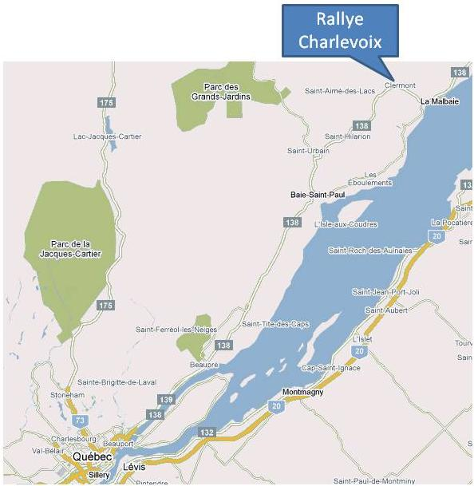

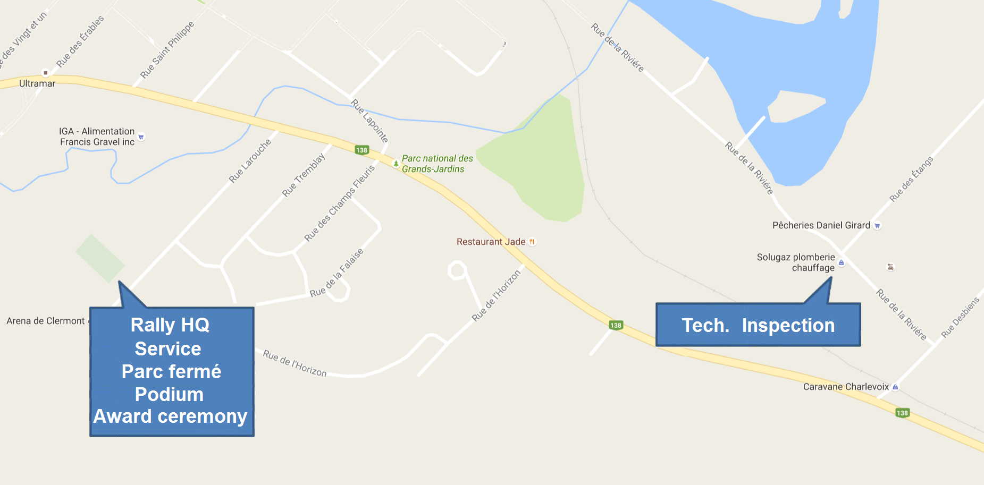

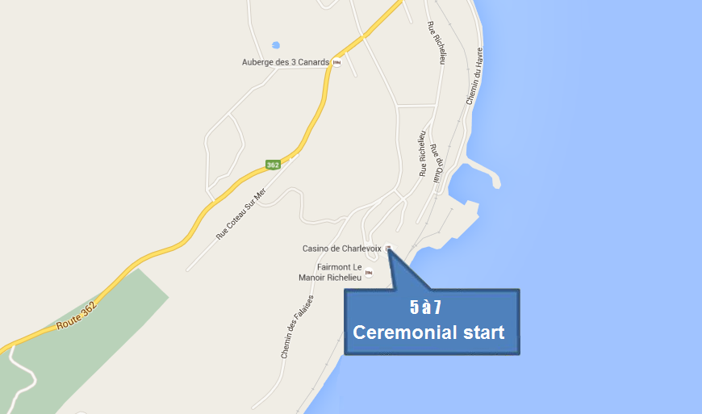

GPS Coordinates
Special Stage |  | IN |  |  | Out
Service area |  | 47° 41' 19.48" N | 70° 13' 27.38" W |  | 47° 41' 16.83" N | 70° 13' 31.64" W
 |  | Start |  |  | Finish
SS1-2 Clermont |  | 47° 41' 40.18" N | 70° 13' 31.27" W |  | 47° 41' 19.38" N | 70° 12' 23.33" W
SS3-8 Lac au sable |  | 47° 45' 03.36" N | 70° 12' 58.31" W |  | 47° 51' 49.37" N | 70° 02' 38.02" W
SS4-9 Port au saumon |  | 47° 51' 45.02" N | 70° 02' 12.02" W |  | 47° 45' 51.21" N | 70° 00' 15.94" W
SS5 Bataram |  | 47° 54' 35.61" N | 70° 03' 00.38" W |  | 47° 45' 10.72" N | 70° 12' 42.86" W
SS6-7 PAX |  | 47° 36' 37.84" N | 70° 19' 31.58" W |  | 47° 35' 14.47" N | 70° 18'05.89" W

9.Entries

a) Entries will be accepted until the end of registration on Friday October 21, at 8 p.m.

b) The maximum number of entries is limited to 60 cars. Additional registrations will be placed on a waiting list.

c) Eligible Vehicles :
Event:
- All classes recognized by regulation of CRQ section 4.2

10. Entry Fees
 | Can
Rallye de Charlevoix | $600
Open Test/Shakedown | $60

a) Included in the fee is an $111 CDN public liability insurance and accidental death and dismemberment levy for insurance coverage during special stages.
Also included in the fees are:
- Road book
- Descriptive Notes
- Odo check will be provided
- Service book
- Two coupons 50% discount for lunch or another at Mc Cafe in La Malbaie

b) All checks or money orders must be made to payable to: RALLYE DE CHARLEVOIX
c) Entries must be sent to the Registrar, Émilie Fortin. Your check confirms your entry. Please kindly note the time of technical inspection and your service area chosen according to the size you need number, you will notice that our pitches are all 30x30 so you choose one or two glued to your needs. You can contact me to find out what time and what location are available when you register or visit the facebook page of the rally, I will post availability.
d) Reimbursement Procedure
All registration fees will be refunded if notice of cancellation is given before Friday, October 21, 2016 at 10 am (EDT).

11. Awards
Trophies will be awarded to the first three finishers in each championship. One principal goal is one day your give award in money.

12. Documentation
The registration form and the waiver are attached to these supplementary regulations along with directions to the shakedown location.

13. Eligibility
Eligibility is as per National Rally Regulations (Section 11 and 12)

14. Timing and Scoring
Timing, Controls and Scoring will be as per NRR sections 15, 16 and 17. Time cards will be used. At the controls identified in the route book, competitors will give the marshal the time card and will then use the next one. All times given will be elapsed times. To calculate the time out at the end of a special stage, the competitors will use the “long” time, unless the time spent in the stage is greater than the long time. In that case, the competitor will use the time at the stage finish in hours and minutes.

Examples:
Car A Car B Car C
Arrival 14:02 14:02 14:02
Start 14:04 14:04 14:04
Finish 14 h 08 m 23 s 14 h 10 m 18 s 14 h 12 m 09 s
MLP 6 m 6 m 6 m
Out times 14:10 14:10 14:12
Transit 18 m 18 m 18 m
Arrival 14:28 14:28 14:30

15. Penalties
The penalties listed in NRR section 17.2 will be replaced by: a penalty of thirty (30) seconds will be given for each chicane element that is moved or knocked down. In addition, bypassing a chicane will result in a one (1) minute penalty. A competitor will be judged to have bypassed a chicane if they: take a line other than the intended line and/or do not keep a minimum of (2) wheels on the asphalt at all times.
16. Judges of Fact
The following persons are considered judges of facts (RNR, 6.3): the officials named in section 6.1.1 of the Competition Rules, the official CARS as listed in section 6.1.2, attendants departures and the observation control posted on the course. The facts may be considered are the time of arrival in areas of special stage starting early departures of classification test, the speeds recorded with a radar gun, belts, windows, helmets, illegal service the decline in a control zone, breaches the use of traffic control devices and safety baffles and what is listed in section 6.3.2 of RNR.

17. Vehicle Advertising
Competition numbers as well as organizer-provided advertising must be affixed to competing cars under pain of exclusion.

18. Fuel stops and Servicing
a) The service book allows planning assistance. It includes, in addition to routes between the points of service:

1 A table showing the total distance traveled by and that run before each scheduled stop for refueling and service;
2 Guidance on the designated points of supply and service. The distance between the stops will not exceed 150 km. 19/02/16 CARS maximum distance between refueling stops fuel, if it is more than 150 km (see 13.2.5 RNR)

The service is allowed only in designated areas only.

b) Service Area Location

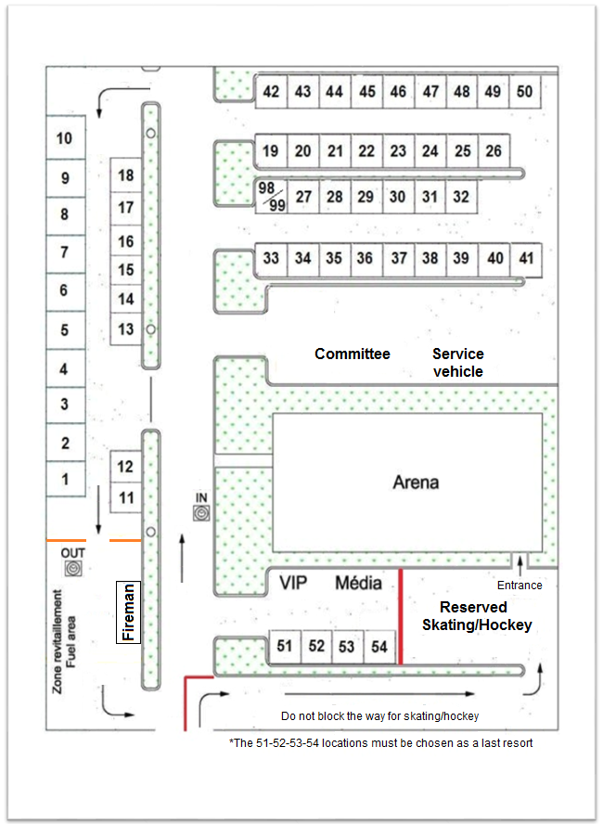

Point your location on the registration form and please keep in mind that each location measure 30x30 and you choose one or two glued to your needs.

c) Refuelling area

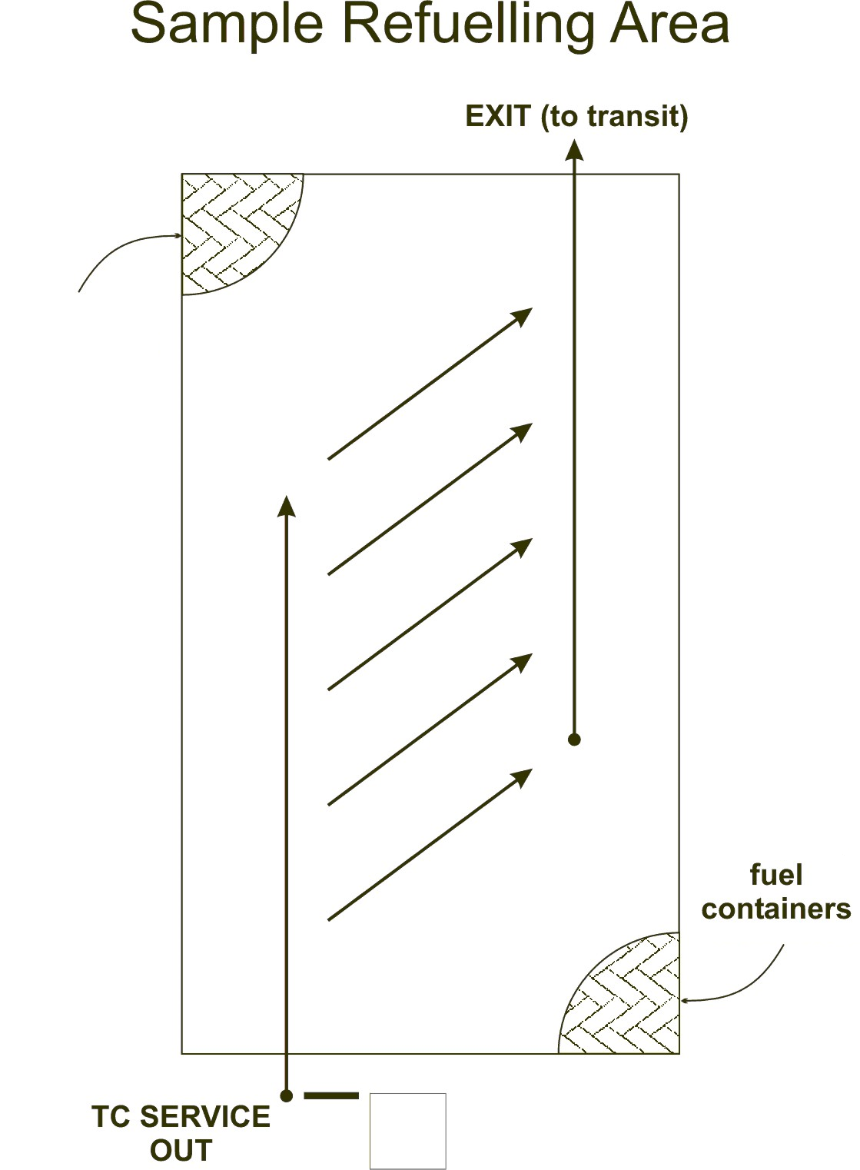

19. Parc Fermé Inspection
Any car finishing the rally in the top three positions of any championship may be inspected if deemed necessary. Reassembling the removed parts will be the competitors’ responsibility.

20. Recce
- All teams registered for the event may participate in the reconnaissance. The organizers will provide a “Tulip”-style route book in addition to a set of descriptive notes.
- The Friday reconnaissance session will be carried out using an open format from 1:00 pm to 5:00 pm. The reconnaissance will be supervised by marshals at the start and finish of each stage. Teams may use their rally car for the reconnaissance. Cars used for reconnaissance must have their competition number affixed to the upper right-hand/co-driver’s side corner of the windshield.

- Schedule the reconnaissance is open.

21. Pavage Rolland Fortier Inc. Shakedown
a) The shakedown will use a 1.5 km stage. Instructions will be provided. Shakedown runs carried out by a registered driver and co-driver may be conducted at competition speeds with all required safety equipment (helmet, harness, HANS, race suits) worn. Shakedown runs carried out by a registered driver and a passenger that is not participating in the rally are to be done for demonstration purposes only. They should not be carried out at high speeds or in competition conditions. Properly adjusted helmets and harnesses are mandatory; however, passengers are not required to wear a race suit or a head and neck restraint system. All passengers must sign a waiver prior to their participation. No competitor is allowed on the shakedown stage outside of the prescribed times listed on the event schedule.

b) The shakedown will use a portion of the La Pax stage.

c) Unloading area: teams can unload their car at the location marked “Debarcadère” on the map or at the service area.

d) The teams will be able to sign the waiver directly on-site.

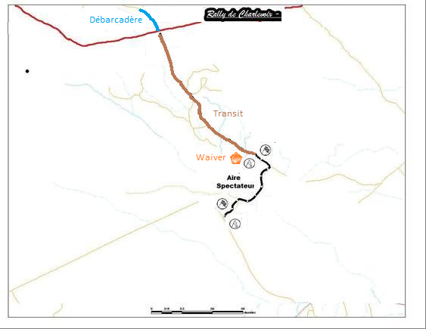

22. Miscellaneous

a) Distances in the route book will be given in kilometres.

b) Reseeding will be based on the results from the special stages. The new starting order will be established based on the total of all stages, minus the worst result. In case of a tie, total time will be the deciding factor.

c) Cars will be started at one (1) minute interval

d) The rally will use a refuelling zone next to the service area.

e) Each team must place a tarp under their rally car in the service area.

f) Championship windshield banners and door panels are mandatory for all cars entering the event.

g) Volunteer gift: Each team must provide a volunteer gift of $25 in value at registration. The gifts will be drawn either during the post-event banquet (depending on the percentage of volunteers attending) or at the volunteers’ party that will be held in November.

h) Warning: Winter tires are recommended for all vehicles used during reconnaissance and it is also recommended that teams bring winter tires for their rally cars. In the case of snow, cars not fitted with winter tires will not be allowed on the reconnaissance.

i) Maximum lateness and official results
- The maximum lateness (NRR 15.5.5) will be 15 minutes at a control
- Provisional results (NRR 20.1.) will be posted at least 15 minutes after the arrival of the last competitor.
- The period to file a protest (NSR 8.2, NRR 23.2) will be 15 minutes in duration.

j) It is mandatory for trailers to be parked at the location specified by the rally organizers (Garage Solugaz). Please mention at registration if you plan to park your trailer at Garage Solugaz and provide your name and a phone number where you can be reached at any time. This will help us manage the closing of the lot’s gate which will be locked. The person that is responsible for locking and unlocking the gate will not be at the event, so please contact them in advance to gain access your trailer.

k) Please do not forget to choose your technical inspection appointment time along with your service area location. You must choose one or two locations as needed, because every location is 30 x 30. Both should be indicated on your entry form.

l) CARS will not issue any licenses at the event. Competitors must obtain their licenses from the CARS’ office before the event.
m) CARS will not issue any Log book at the event. Competitors must obtain their log book prior to the event.

n) The ceremonial start is important for the event and its new financial partner so be this please: 8:15 p.m. at the Casino de Charlevoix. The ceremonial start is obligatory.

23. Lodging/Restaurant
You are a special price for you in this lodging!!!

Fairmont Manoir Richelieu
183 rue Richelieu
La Malbaie, Qc
G5A 1X8
1-888-610-7575
http://www.fairmont.fr/richelieu-charlevoix/
Room : 115$ for people of rally

Motel du Restaurant Chez Pierre
2020 Boul de Comporté
La Malbaie (Québec), G5A 1N2
418-665-3718 or 1-800-361-3718
Rates :
Single Room: $49
Double Room: $59
Le Mirage
185 Boulevard de la Comportée
La Malbaie (Québec), G5A 2Y3
1-800-263-6421
www.motellemirage.com

Petit Manoir du Casino
525 chemin des Falaises
La Malbaie (Québec), G5A 2V5
1-800-618-2112
www.petitmanoirducasino.ca

Domaine Frais Air
30 du Domaine
La Malbaie (Québec)
G5A 0A5
(418) 665-3318
domainefraisair@videotron.ca

La Remontée
95, Côte Bellevue, C.P. 1261
La Malbaie, Qc.
G5A 3A7
418 665-3757
www.laremontee.com

Hotel le Petit Berger
20, rue Desbiens
La Malbaie QC G5A 3C1
1 800 314-4428
info@hotelaupetitberger.com

Important: Please mention that you are attending the Rallye de Charlevoix when booking so that the receptionist can note this on your reservation. Thanks!

Mc Café
635 Boulevard de la Comporté
La Malbaie, Qc.
G5A 2Y3
418 665-7400
(You have a 50% discount on a line with the delivery of your coupon you find in your envelope registration)

Le Corail
110 Boulevard Notre Dame
Clermont (Québec)
418-439-3752
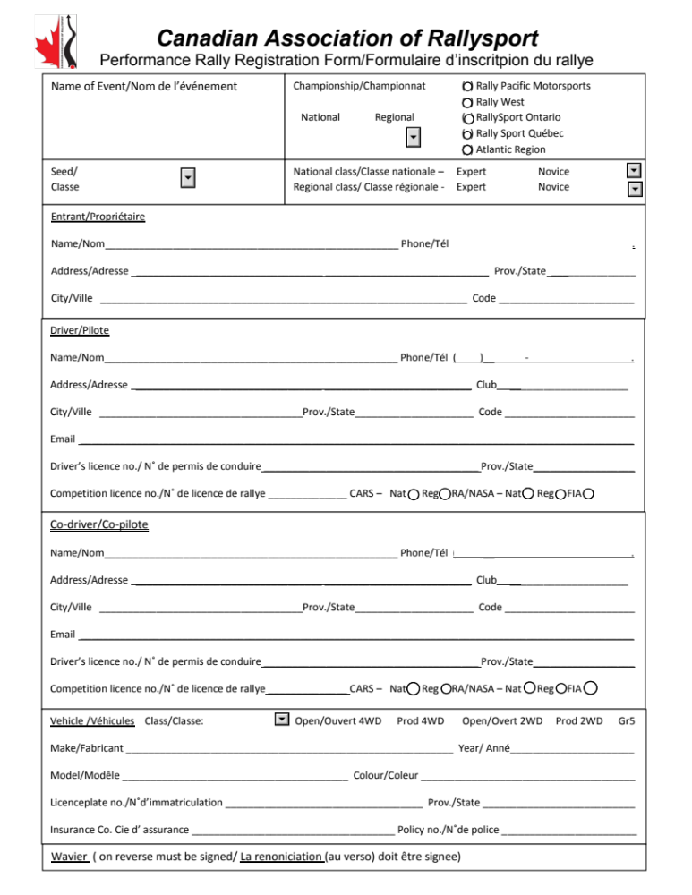
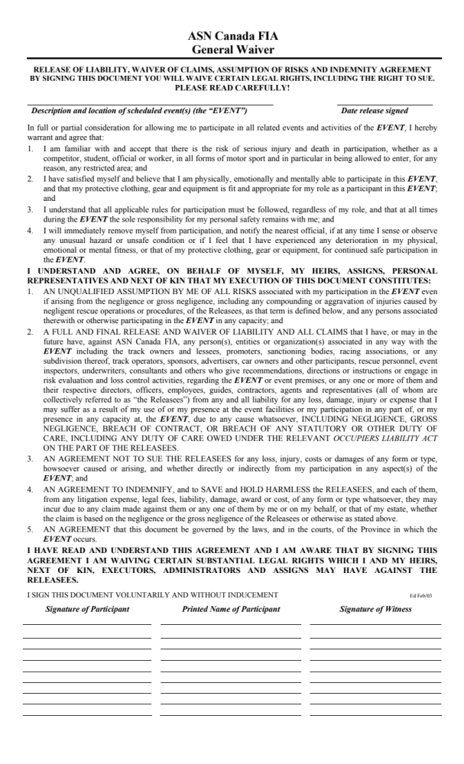
Horaire du Rallye de Charlevoix 2016
 |  |  |  |  |  |  | 00:02:00
 |  |  |  |  | km E.C. | km liaison | Temps | Voiture "0" | Voiture "0" | Voiture ''99''
 |  |  |  |  |  |  |  | départ | sortie
C.H.M.a Départ Protocolaire |  |  |  |  | Vendredi 23 Octobre |  |  | 20:15
C.H.M.b Début du Rallye |  |  |  |  | Samedi 24 Octobre |  |  | 08:25 |  | 09:11
C.H. 1 |  |  |  |  |  | 1,32 | 00:07 | 08:32 |  | 09:18
E.C. 1 Clermont #1 |  |  |  |  | 2,23 |  | 00:05 | 08:34 | 08:39 | 09:23
C.H. 2 |  |  |  |  |  | 1,92 | 00:40 | 09:19 |  | 10:03
E.C. 2 Clermont #2 |  |  |  |  | 2,23 |  | 00:05 | 09:21 | 09:26 | 10:10
C.H.S1a Service 1 |  |  |  |  |  | 1,47 | 00:05 | 09:31 |  | 10:15
Service 1 Arena Clermont |  |  |  |  |  | 0,00 | ~0:20
C.H.S1b sortie de service 1 |  |  |  |  |  | 0,00 |  | 09:51 |  | 10:35
C.H. 3 (ravitaillement inclus) |  |  |  |  |  | 13,19 | 00:28 | 10:19 |  | 11:03
E.C. 3 Lac-Aux-Sables #1 |  |  |  |  | 21,90 |  | 00:20 | 10:21 | 10:41 | 11:25
C.H. 4 |  |  |  |  |  | 1,31 | 00:06 | 10:47 |  | 11:31
E.C. 4 Port aux saumons #1 |  |  |  |  | 17,00 |  | 00:15 | 10:49 | 11:04 | 11:48
C.H. 5 (ravitaillement optionnel) |  |  |  |  |  | 39,78 | 00:48 | 11:52 |  | 12:36
E.C. 5 Bataram |  |  |  |  | 35,1 |  | 00:35 | 11:54 | 12:29 | 13:13
C.H.S2a Service 2 |  |  |  |  |  | 10,41 | 00:18 | 12:47 |  | 13:31
Service 2 Arena Clermont |  |  |  |  |  | 0,00 | ~0:45
C.H.S2b sortie de service 2 |  |  |  |  |  | 0,00 |  | 13:32 |  | 14:16
C.H. 6a Regrouping |  |  |  |  |  | 0,00 | 00:10 | 13:42 |  | 14:26
C.H. 6b (ravitaillement inclus) |  |  |  |  |  | 15,40 | 00:30 | 14:12 |  | 14:56
E.C. 6 La Pax #1 |  |  |  |  | 3,89 |  | 00:05 | 14:14 | 14:19 | 15:03
C.H. 7 |  |  |  |  |  | 0,34 | 00:50 | 15:09 |  | 15:53
E.C. 7 La Pax #2 |  |  |  |  | 3,89 |  | 00:05 | 15:11 | 15:16 | 16:00
C.H.S3a Service 3 |  |  |  |  |  | 14,30 | 00:18 | 15:34 |  | 16:00
Service 3 Arena Clermont |  |  |  |  |  | 0,00 | ~0:20
C.H.S3b sortie de service 3 |  |  |  |  |  | 0,00 |  | 15:54 |  | 16:20
C.H. 8 (ravitaillement inclus) |  |  |  |  |  | 13,19 | 00:28 | 16:22 |  | 16:20
E.C. 8 Lac-Aux-Sables #2 |  |  |  |  | 21,90 |  | 00:20 | 16:24 | 16:44 | 17:28
C.H. 9 |  |  |  |  |  | 1,31 | 00:06 | 16:50 |  | 17:34
E.C. 9 Port aux saumons #2 |  |  |  |  | 17,00 |  | 00:15 | 16:52 | 17:07 | 17:51
C.H.M. 10 Fin du Rallye |  |  |  |  |  | 26,46 | 00:30 | 17:37 |  | 18:21
 |  |  |  |  | Total E.C. (km) | Total rallye (km) | Total temps
 |  |  |  |  | 125,14 | 265,54 | 08:49
Paramètres :
Début du rallye (voiture 0) |  |  |  |  | 08:25
Nombre de participants (inclus 99) |  |  |  |  | 40
Temps de préparation au début de chaque spéciale |  |  |  |  | 00:02:00
Temps entre compétiteurs au C.H.0 |  |  |  |  | 00:01:00
Temps entre voiture 0 et autres compétiteurs |  |  |  |  | 00:04:00
Service 1 |  |  |  |  | 00:20:00
Service 2 |  |  |  |  | 00:45:00
Service 3 |  |  |  |  | 00:20:00
 |  |  | 15-10-05

Example of Descriptive Notes :

SS 1-2 Clermont (Fr) Page: 1 de 2

Start 170 KG → R2 100 D5P 50 Turn L3P + Turn G3onto BR + !TurnR3@T → L3 → R3 + L3M lg wide/C → chicane → !Turn L3M@T → R3Mdc → L3↓ → !Brake Turn R3-@T +

R5@JCT + R4 cont/C +

